Iteration 4 Review

Contents

Implemented User Stories 2

Story ID: 11 - OAuth 2

Story ID: 12 – Configure LAN Server 2

Related Progress 2

CSS 2

Mobile Access / View Switcher 3

Class Diagram 3

Database Schema 5

Entity Framework 5

SMO Database 6

Release Plan 7

Difficulties and Learning Outcomes 8

Story ID: 11 - OAuth 8

CSS 8

Mobile View / View Switcher 8

State diagram 8

Interaction diagram 9

# Implemented User Stories

### Story ID: 11 - OAuth

User can log in using an existing Facebook/Google account. There are no limitations in app functionality if the user logs in this way. When logging in for the first time, the user will be asked to provide a user name, which is set by default to the users full name taken from the third party. The application is configured to enable log ins using Twitter, but the twitter OAuth API requires that they be provided with a live accessible URL before this will function correctly.

### Story ID: 12 – Configure LAN Server

The application is now configured to run locally on any machine and allow incoming connections to access the application using the local hosts IP address. This allows us to test the application across multiple operating systems. We have discovered issues with the CSS through this type of testing.

# Related Progress

### CSS

The default ASP.NET MVC style has been modified to better reflect main purpose of the application. The new CSS is skeuomorphic in nature. The layout is designed to resemble a notepad lying on a desktop table. The text on the site is styled to be reminiscent of handwritten notes. We used a mnemonic approach to some icons on the site, in particular, form actions (edit/delete/export). We hope these icons improve the usability for the user, and will implement tooltips to avoid any possible confusion.

An image slider powered by JavaScript (taken from [Menu Cool](http://www.menucool.com/javascript-image-slider)) has been added to the Home page, this will eventually house images that give the user an overview of the applications functionality and how to use it.

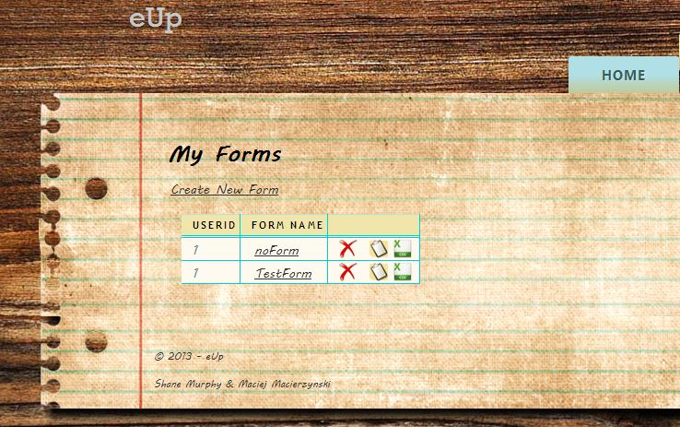

### Mobile Access / View Switcher

User accessing the application from a mobile device will be presented with a mobile version of user interface. For this purpose we have chosen to use a JQuery Mobile framework. JQuery provides good integration with ASP.NET MVC and HTML5, which we plan to use later for local data storage. More mobile views are to be added in the next iteration to allow the mobile version to provide all the necessary functionality to work as a standalone application from the full web version.

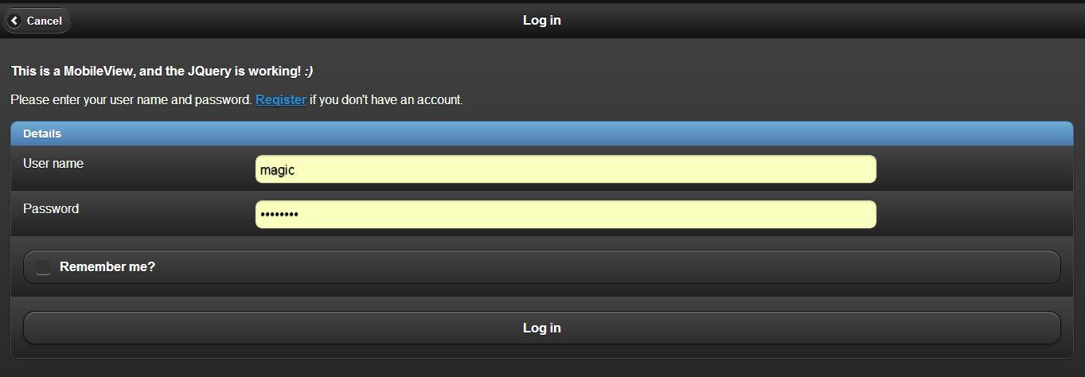

# Class Diagram



# Database Schema

### Entity Framework



### SMO Database



# Mountain Lion:Users:shanemurphy:Dropbox:3rdYearImagineCup:Submitions:Upload 4 - 5th April:Release Plan.pngRelease Plan

# Difficulties and Learning Outcomes

### Story ID: 11 - OAuth

Each service (Facebook/Google/Twitter) has a different way of generating an AppID and AppSecret values. Once we obtained these values, we could integrate them into our application code in AuthConfig configuration file.

### CSS

To accommodate the images inside the JavaScript image slider on the Home page, we decided to keep the website at a fixed width, which is always centred in the users browser.

The navigation tabs appear out of line on some operating systems and browsers, we are working to fix this in the next iteration.

### Mobile View / View Switcher

Some time was spent troubleshooting the mobile views and CSS. As the JQuery within the views was not being loaded within the mobile view. The cause of this turned out to be a JQuery Mobile package version. After reinstating a previous version of the package, the problem was resolved.

# State diagram



# Interaction diagram

